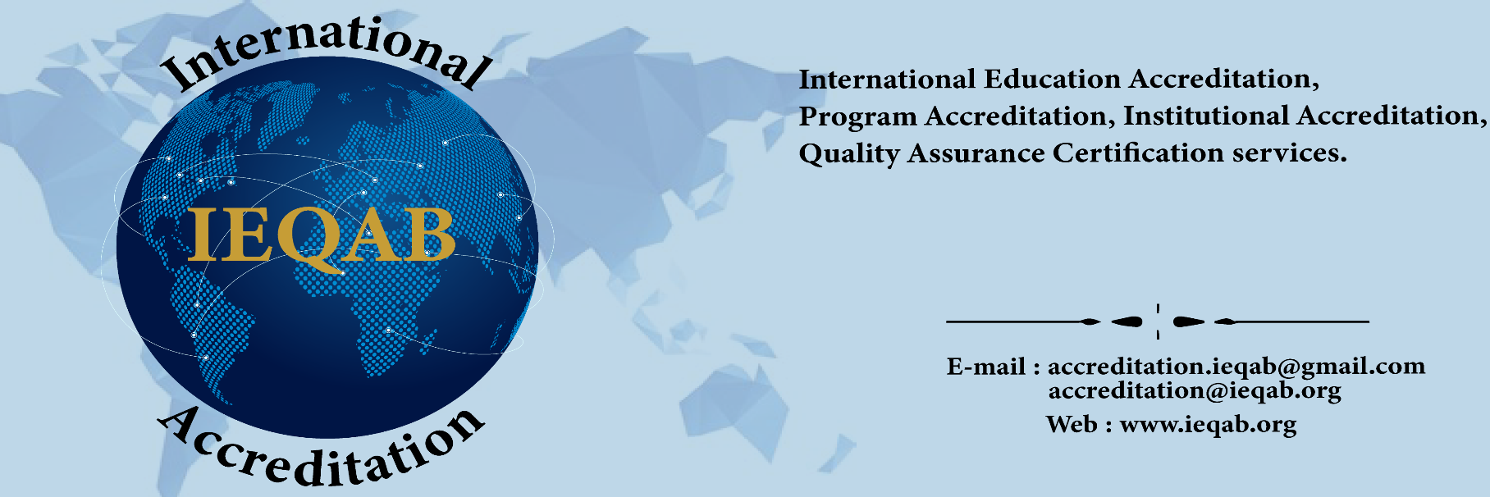
International Education Quality Accreditation Body – IEQAB
Email: accreditation@ieqab.org Website: www.ieqab.org

Institutional Accreditation Self-Assessment Report Form

For Online / Off Campus Organization/Institutions

IEQAB Member Number: ( IEQAB Member No. will be filled by IEQAB authority)
Institution Name:
Primary Contact Officer/CEO & Professional/Online Adult Higher Education Institution Contact
Name/Title:
Email Address:
Website Address:
WhatsApp/Mobile or Cellular Number:
Telephone Number:
Professional/Online Adult & Higher Education Institution Information
Please provide the following necessary documents:
- Organizational Chart or Organogram.
- Organization’s Mission Statement, Governance (with links to the mission statement on website, course catalogues, brochures, leaflets etc.)
- Institutional Policies and Procedures (for academic programs, student support services, faculty and staff guidelines, and administrative operations.
- Institutional Environment (please describe your institution’s environment and key relationships with students and other stakeholders)
- Staff –Administrative/Management and Faculty CVs/ Resumes.

Primary Study Program Contact
Name/Title:
Email Address:
WhatsApp/Mobile Number:
Telephone Number:
Study Program Information
Please provide a list of study programs the Academic Institution/Professional Academy wishes to be accredited by IEQAB with the study program URL.

[ A] Physical Class based programs ( if any):
Study Program:
URL:

Study Program:
URL:

Study Program:
URL:

[ B] Online Class based programs:
Study Program:
URL:

Study Program:
URL:

Study Program:
URL:

Please provide the following necessary documents for each of the study programs mentioned above:

- Academic or Professional Program Structure (with program description, program aims, program learning outcomes, credit units/ECTS, list of core courses and elective courses, etc.)
- Course Outlines/Syllabi (with course description, learning objectives, credit units/ECTS, total learning hours, subjects/topics, type of assessments, etc.)
- Copies of course assessments documents and grading rubrics (tests, exams, projects, practical observation, presentations, etc)

- List of faculty and courses they teach
- Faculty CVs/resumes or Faculty Qualification/Biography
- Degree transcripts samples and certificates Samples.
- Course self-evaluation survey results
- Teacher self-evaluation survey results

If the Institution has an online learning portal/platform or LMS accessible by students and faculty, please provide “Guest Access” to the learning portal/platform or LMS for the above study programs.
Date - Institutional Accreditation Self-Assessment Form Submitted: (Day – Month –Year):

Signature and Seal - (Authorized Official of the Institution):

Submission Instructions

- Complete the form and send this form along with all the required documents to Email: accreditation@ieqab.org
- If this form submitted partially then it’ll be treated as incomplete and have to resubmit missing documentation.
- Assessment fees or Evaluation Fees of EUR 50 (non-refundable). Please make sure, assessment fees is PAID status. Otherwise you should ask for PayPal link or IEQAB authorized Bank Account details.

